|  |  |  |  |  |  |  |  |  |  |  |  |  |  |  |  |  |  |  |  |  |  |  |  |  |  |  |  |  |  |  |  |  |  |  |  |  |  |  |  |  |  |  |  |  |  |  |  |  |  |  |  |  |  |  |  |  |  |  |  |  |  |  |  |  |  |  |  |  |  |  |  |  |  |  |  |  |  |  |  |  |  |  |  |  |  |  |  |  |  |  |  |  |  |  |  |  |  |  |  |  |  |  |  |  |  |  |  |  |  |  |  |  |  |  |  |  |  |  |  |  |  |  |  |  |  |  |  |  |  |  |  |  |  |  |  |  |  |  |  |  |  |  |  |  |  |  |  |  |  |  |  |  |  |  |  |  |  |  |  |  |  |  |  |  |  |  |  |  |  |  |  |  |  |  |  |  |  |  |  |  |  |  |  |  |  |  |  |  |  |  |  |  |  |  |  |  |  |  |  |  |  |  |  |  |  |  |  |  |  |  |  |  |  |  |  |  |  |  |  |  |  |  |  |  |  |  |  |  |  |  |  |  |  |  |  |  |  |  |  |  |  |  |  |  |  |  |  |  |  |  |  |  |  |  |  |  |  |  |  |  |  |  |  |  |  |  |  |  |  |  |  |  |  |  |  |  |  |  |  |  |  |  |  |  |  |  |  |  |  |  |  |  |  |  |  |  |  |  |  |  |  |  |  |  |  |  |  |  |  |  |  |  |  |  |  |  |  |  |  |  |  |  |  |  |  |  |  |  |  |  |  |  |  |  |  |  |  |  |  |  |  |  |  |  |  |  |  |  |  |  |  |  |  |  |
| --- | --- | --- | --- | --- | --- | --- | --- | --- | --- | --- | --- | --- | --- | --- | --- | --- | --- | --- | --- | --- | --- | --- | --- | --- | --- | --- | --- | --- | --- | --- | --- | --- | --- | --- | --- | --- | --- | --- | --- | --- | --- | --- | --- | --- | --- | --- | --- | --- | --- | --- | --- | --- | --- | --- | --- | --- | --- | --- | --- | --- | --- | --- | --- | --- | --- | --- | --- | --- | --- | --- | --- | --- | --- | --- | --- | --- | --- | --- | --- | --- | --- | --- | --- | --- | --- | --- | --- | --- | --- | --- | --- | --- | --- | --- | --- | --- | --- | --- | --- | --- | --- | --- | --- | --- | --- | --- | --- | --- | --- | --- | --- | --- | --- | --- | --- | --- | --- | --- | --- | --- | --- | --- | --- | --- | --- | --- | --- | --- | --- | --- | --- | --- | --- | --- | --- | --- | --- | --- | --- | --- | --- | --- | --- | --- | --- | --- | --- | --- | --- | --- | --- | --- | --- | --- | --- | --- | --- | --- | --- | --- | --- | --- | --- | --- | --- | --- | --- | --- | --- | --- | --- | --- | --- | --- | --- | --- | --- | --- | --- | --- | --- | --- | --- | --- | --- | --- | --- | --- | --- | --- | --- | --- | --- | --- | --- | --- | --- | --- | --- | --- | --- | --- | --- | --- | --- | --- | --- | --- | --- | --- | --- | --- | --- | --- | --- | --- | --- | --- | --- | --- | --- | --- | --- | --- | --- | --- | --- | --- | --- | --- | --- | --- | --- | --- | --- | --- | --- | --- | --- | --- | --- | --- | --- | --- | --- | --- | --- | --- | --- | --- | --- | --- | --- | --- | --- | --- | --- | --- | --- | --- | --- | --- | --- | --- | --- | --- | --- | --- | --- | --- | --- | --- | --- | --- | --- | --- | --- | --- | --- | --- | --- | --- | --- | --- | --- | --- | --- | --- | --- | --- | --- | --- | --- | --- | --- | --- | --- | --- | --- | --- | --- | --- | --- | --- | --- | --- | --- | --- | --- | --- | --- | --- | --- | --- | --- | --- | --- | --- | --- | --- | --- | --- | --- | --- | --- | --- | --- | --- | --- | --- | --- | --- | --- | --- | --- | --- | --- | --- | --- | --- | --- | --- | --- | --- | --- | --- | --- | --- | --- | --- | --- | --- | --- | --- |
| **7.2.1**  **QlM** | **Describe two best practices successfully implemented by the Institution as per NAAC format provided in the Manual.**  **Best Practice:1**  **Title of Best Practice**: **Providing Assistance (Financial and Books) to the needy students**   1. **Objectives of the Practice:**   Education is the single most important factor which can greatly enhance quality of life of a student and enhance his/her outlook and vision towards the different aspects of life.  But there are few unfortunate ones who have the desire to excel and educate themselves but are financially incapable of doing so. With the help of this practice we aim to provide education to the less fortunate ones and illuminate their future with hope and knowledge. Various departments have also set up Book Banks whereby free books are provided to the students who are financially weak.   1. **The Context:**   At the time of admission and in our classrooms we come across such students who are willing to obtain higher education but are restricted by their poor financial condition. The challenge is to arrange financial assistance through various NGOs, individuals and associations so that maximum number of students can be benefitted. Right to Education act has made great impact and the access to education has increased. Free education in government schools has been a boon for many students. But dreams of many are crushed due to lack of finances and they might be forced to abandon their educational desires. The scheme has been designed and is implemented in such a way that maximum number of students can take advantage of it. Book banks are set up to further help the students who are not financially sound.   1. **The Practice:**   The institution has been approached by several humanitarian and philanthropist associations and individuals who are willing to provide financial assistance to needy students in form of fees or scholarships.  The practice is unique in itself as it is not being done in response to any instructions and guidelines issued by government. But it is an impromptu effort by the institution to spread the light of knowledge far and wide and into the darkest corners.  The institution has been providing financial help to students with the help of many organizations, individuals and under government schemes.  Book banks are established in different departments of college to help the needy students. Under this program, books are issued from the book bank to the needy students for the whole semester. After exams they return the books and they are issued books for the new semesters.  These book banks are maintained from extra complimentary copies received by teachers, books donated by old students etc.  The major constraint faced in providing financial assistance to students is to arrange enough finances to help all the students completely.  Book bank faces a few issues like some of the pass out students may not return books or the books may be insufficient for the number of students actually needing the books.  **Name of the scheme (Providing Financial Assistance to the students)**   1. Post Matric Scheme For SC Students 2. Central Sector Scheme Of Scholarship 3. National Scholarship For Post Graduate 4. Student Aid Fund 5. Red Cross/Humanitarian Aid Fund 6. M/S Disha Education Welfare Trust 7. M/S Brij Lal Gupta Kanta Devi Charitable Trust 8. M/S Sangeeta Dutt Memorial Forum 9. M/S Gurdial Singh Kelley & Village 10. M/S Bimla Devi Charitable Trust 11. M/S Govt. Satya Bharti Adarsh Senior 12. Mata Gurdev Kaur Memorial 13. Sports Stipend 14. Prof. M.S. Hundal Academic Excellence Award 15. Chemistry Faculty Award 16. **Evidence of Success:**   The efforts made by institution over the years have borne fruit and many students have successfully graduated from this college due to the aid provided to them.   |  |  |  |  |  |  |  |  |  |  |  |  |  | | --- | --- | --- | --- | --- | --- | --- | --- | --- | --- | --- | --- | --- | | **Year** | **Name of the scheme** | | **No. of students benefitted by Govt. Schemes** | | | | **Number of students benefitted by Institution’s efforts** | | | | | | | **No. of students** | **Amount** | | | **Number of students** | | | | | **Amount** | | **2023-24** | **Post Matric Scheme for SC students** | SC Fresh | 85 | 1951768 | | |  | | | | |  | | SC Renewal | 88 | 1916020 | | | | OBC |  |  | | |  | | | | |  | | **Total** | | **173** | **3,867,788** | | | |  | | |  | | | **Central Sector Scheme of scholarship for colleges** | |  | | | | | | | | | | | Minority Fresh | | 0 | | 0 | | | |  | | | | | Merit Fresh | | 17 | | 204000 | | | | | Merit Renewal | | 28 | | 336000 | | | | | Students with Disability Renewal | | 01 | | 12000 | | | | | **Total** | | **46** | | **5,52,000** | | | |  | | | | | **National Scholarship for Post graduates** | | **1** | | **10,500** | | | |  |  | | | | **Grand Total** | | **220** | | | **4,430,288** | | |  |  | | | | Student Aid Fund | |  | | | | | | 14 | 1,84,800 | | | | Red Cross/ Humanitarian Aid Fund | |  | | | | | | 22 | 33,500 | | | | M/s Disha Education welfare trust | |  | | | | | | 03 | 7,230 | | | |  | M/s Brij Lal Gupta Kanta Devi Charitable trust | |  | | | | | | 39 | 1,34,500 | | | |  | M/s Sangeeta Dutt Memorial Forum | |  | | | | | | 04 | 42,070 | | | |  | M/s Gurdial Singh Kelley& Village | |  | | | | | | 10 | 20,000 | | | |  | M/s Bimla Devi Charitable Fund | |  | | | | | | 03 | 5,490 | | | |  | M/s Govt Satya Bharti Charitable Trust | |  | | | | | | 07 | 1,40,000 | | | |  | Mata Gurdev Kaur Matharu Memorial fund | |  | | | | | | 30 | 58,500 | | | |  | Sports Stipend | |  | | | | | | 14 | 98,580 | | | |  | Prof.M. S. Hundal Academic Excellence Award | |  | | | | | | 01 | 5,000 | | | |  | Chemistry Faculty Award | |  | | | | | | 01 | 5,000 | | | |  |  | | **TOTAL** | | | | | |  | **7,34,670** | | |   The efforts made by institution and their tangible results can be seen in this table provided. These numbers prove that a large number of students benefitted from these efforts and got admission in different courses.   1. **Problems Encountered and Resources Required**   Conceptualization and implementing any noble deed is always rampant with several hiccups and problems. The major problem faced was to find enough donors for providing financial assistance to maximum number of students. While implementing the assistance at college level, the students are interviewed to assess their financial status and to verify their claims.  Book bank faces problems like shortage, non return of books by students and the books progressively becoming poor in condition due to usage over the years.    **Best Practice:2**  **Title of the Practice: Participation in Extracurricular Activities**   1. **Objectives of Practice:**   The intended outcome of this practice is to ensure all round development of the students. Education is not just the knowledge of books but it also lies in knowing and testing our capabilities in different fields like sports, cultural activities etc.   1. **The Context:**   Some people are of the view that extracurricular activities are a waste of time and they take us away from books hence will lead to poor performance in exams. In fact, active and well performing students are good at extracurricular activities as well as studies too. The students can learn to balance their studies with other activities this is an important skill which would be quite useful in their work years too.  The college has always encouraged students to hone their skills in creative arts, stage performance, debates, sports etc by organizing various events for them.   1. **The Practice**   A sizeable number of our students participated in Zonal and Inter Zonal Youth and Heritage Festivals of Panjab University and brought laurels to the institution by winning prizes in their respective fields of participation.  The institution has a strong tradition of enthusiastic participation and superlative performances. Students are provided constant guidance and professional coaching to get the best results. Students getting positions in youth festivals get benefit during admissions for higher studies in university.  It can be said that results speak for themselves.  In the field of sports also, the achievements of our students are worth mentioning. A good number of students made the college proud by winning prizes in their respective participation categories.   1. **Evidence of Success**   As the saying goes action speaks louder than words. Some of the extracurricular activities of our students are summarized below;   1. **Panjab University Zonal Youth and Heritage Festival**   **(2nd Runner Up Trophy)**   |  |  | | --- | --- | | **Panjab University Zonal Youth and Heritage Festival (Ludhiana Zone A) organized by KLSD College, Ludhiana from 13-10-2023 to 16-10-2023** | | | **Number of students Participated** | **Overall**  **Position** | | 168+  35 accompanists | 2nd Runner Up Trophy |   A. S. College Khanna gave a sterling performance by winning **46 prizes in total** and lifted the2nd Runner Up trophy in the **Panjab University Zonal Youth festival** held at KLSD College, Ludhiana. The Students representing A.S. College Khanna won **11 first positions** in the events of Collage Making, Clay Modelling, Folk Song, Hindi Hand-Writing, Kali, Group Song (Individual), Kali (Individual),Folk Orchestra, Folk Instrument, Muhavredar vaartalap and Folk Orchestra (Individual). Our students won **16 second positions** in the events of Punjabi Handwriting, Geet, Shabad(Team), Group Song, Bagh, Knitting, Phulkari, Still Life Drawing, Shabad (Individual),   Heritage Quiz, Vaar, Play(Individual),Vaar (Individual), Mitti de khidaune, Naala making and Ladies Traditional Song. We bagged **19 third positions** in the events of Poetry Writing, Classical Vocal, Pakhi, Histrionics, Poster, Kavishri (Individual), Group Dance (Individual), Play(Individual),  Percussion, Peerhi Making, Chikku Making, Mimicry, Folk Orchestra (Individual), Bhand (Individual), Skit (Individual), Mime (Individual), Gidhha, Luddi, Gidhha (Individual).  **(ii) Panjab University Inter Zonal Youth and Heritage Festival hosted by Dev Samaj College for Women, Ferozepur from 3-11-2023 to 6-11-2023**  In the 64th Panjab University Inter Zonal Youth and Heritage Festival held at Dev Samaj College for women, Ferozepur, The Kali team of the college comprising Mr. Pushpinder Kumar, Mr. Navkanwar Singh Mandair and Gurkirat Singh won first prize. Maninder Singh won third position in Folk Instruments.   |  |  |  | | --- | --- | --- | | **Panjab University Inter Zonal Youth and Heritage Festival** | | | | Number of 1st Prizes | Number of 2nd Prizes | Number of 3rd Prizes | | 01 | ----- | 01 |   **(iii)** **State level Inter University youth festival held at Guru Nanak Dev University, Amritsar on 30-11-2023.**  The Kali team of the college has carved a niche for itself in Punjab. This team represented Panjab University Chandigarh in the State level Inter University youth festival held at Guru Nanak Dev University, Amritsar on 30-11-2023 and won third prize. The Kali team has won a prize in the State level festival for the third year in a row. The team was awarded University Colour for their marvelous achievement.   |  |  |  |  |  |  | | --- | --- | --- | --- | --- | --- | | **Year** | **Name of the Award/**  **Medal** | **Team/**  **Individual** | **University /state/ National/ International** | **Sports/**  **Cultural** | **Name of the Student** | | 2023 | University Colour | Team- Kali Singing | State | Cultural | Pushpinder Singh | | 2023 | University Colour | Team: Kali Singing | State | Cultural | Navkaran Singh Mandair | | 2023 | University Colour | Team: Kali Singing | State | Cultural | Gurkirat Singh |   **The Achievements of students in the field of sports were also par excellence during the year 2023-24 which is evident from the results as given below;**   * Students of the college excelled in International, National and Inter varsity tournaments. Their achievements particularly in the field of Karate were commendable. * **Varun Kumar Joshi**, M.A. I History, of the college represented India and won Gold Medal at 7th South Asian Karate Championship 2023 held at Kathmandu, Nepal. He represented Panjab University in North zone Inter-versity and won gold medal in team Kumite and bronze medal in individual event. At All India University Karate competition, he secured gold medal at individual event**.** * **Shivam,** B.A. III of collegewon two Bronze medals at 7th South Asian Karate Championship 2023 at Kathmandu, Nepal. He won gold medal in individual event and Bronze medal in team event at All India National Karate Championship 2023 held at Uttrakhand. He represented Panjab University in North zone Inter-versity and won two gold medals in team Kumite and in individual events respectively. At All India University Karate competition, he secured gold medal in individual event**.** * **Manav Joshi,** B.A.II of the college won two gold medals in North Zone Karate Championship in U-21 and senior categories held at New Delhi. He won silver medal in U-21 and Bronze medal in senior category in Interzone Karate championship held at New Delhi. He won Bronze medal in All India Shikokai Karate Championship 2024. He represented Panjab University in North zone Inter-versity and won gold medal in team kumite and bronze medal in individual event. At All India University Karate competition, he secured gold medal in individual event. * **Shivani,** B.A.I of the collegerepresented Panjab University in North zone Inter-versity and won silver medal in team Kumite and bronze medal in individual event**.** |
|  | |  |  |  |  |  | | --- | --- | --- | --- | --- | | **Year** | **Name of the award/ medal** | **Team / Individual** | **University/State/**  **National/ International** | **Name of the student** | | **2023** | **Gold** | **Individual- karate** | **International** | **Varun Kumar Joshi** | | **2023** | **Gold** | **Team-**  **Kumite** | **North Zone Inter University** | **Varun Kumar Joshi** | | **2023** | **Gold** | **Individual-Karare** | **All India Inter University** | **Varun Kumar Joshi** | | **2023** | **Bronze** | **Individal-Karate** | **North Zone Inter University** | **Varun Kumar Joshi** | | **2023** | **2 Bronze** | **Individual-**  **Karate** | **International** | **Shivam** | | **2023** | **gold** | **Individual- Karate** | **National** | **Shivam** | | **2023** | **Bronze** | **Team- Kumite** | **National** | **Shivam** | | **2023** | **Gold** | **Team- Kumite** | **North Zone Inter University** | **Shivam** | | **2023** | **Gold** | **Individual- Karate** | **North Zone Inter University** | **Shivam** | | **2023** | **2 Gold** | **Individual- Karate** | **North Zone(U-21 and Senior categories)** | **Manav Joshi** | | **2024** | **Bronze** | **Individual- Karate** | **All India Shikokai** | **Manav Joshi** | | **2023** | **Gold** | **Team-**  **Kumite** | **North Zone Inter University** | **Manav Joshi** | | **2023** | **Bronze** | **Individual-Karate** | **North Zone Inter University** | **Manav Joshi** | | **2023** | **Gold** | **Individual-Karate** | **All India Inter University** | **Manav Joshi** | | **2023** | **Bronze** | **Individual-Karate** | **North Zone Inter University** | **Shivani** | | **2023** | **Silver** | **Team-**  **Kumite** | **North Zone Inter University** | **Shivani** |   **Problems encountered and Resources required**  Identifying and isolating the best talent from amongst a large pool of students is a difficult task. Apart from this the best of the talent requires nurturing and sharpening the skills with the intervention of specialized coaching and guidance. Talented coaches are difficult to come by and also require monetary investment. The participating students must also be well nourished hence their nutritional requirements are also taken care of by the institution. It is thus clear that these are not only the accomplishments of students but an outcome of intensive funding and backing by the college also. |



**Book Bank record maintained by the Commerce department**

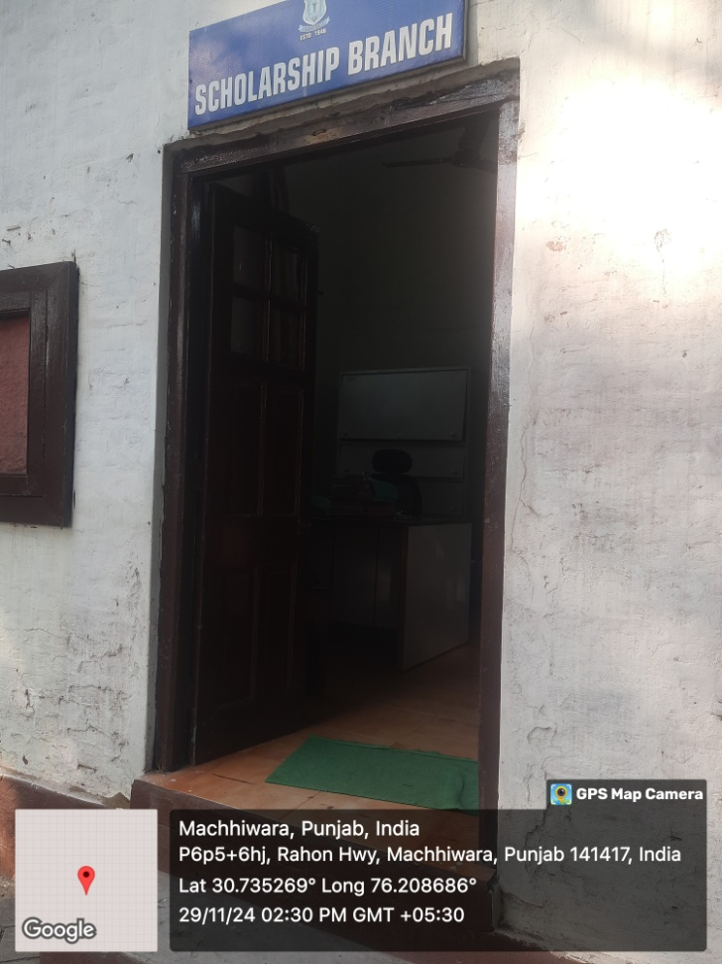

**Scholarship branch in the college to facilitate students for various scholarships**